|  |  |
| --- | --- |
| **Major Indices** *(taken from Trading View)* | |
| S&P 500 | **-1.16%** |
| DOW JONES | **-0.3%** |
| NASDAQ | **+1.93%** |
| FTSE 100 | **-3.65%** |
| DAX | **-3.37%** |
| Nikkei 225 | **-2.41%** |
| Shanghai Composite | **-0.17%** |

- NASDAQ is seeing its best start to a year since 1883

- S&P 500 this year has doubled its average annual return

**R**

S&P 500 Sectors

S&P 500 Technical Chart

**US Jobs Report Release**

## US unemployment rate fell to 3.6% in this month’s Jobs Report, meeting expectations

US Unemployment (Bureau of National Statistics)

* US employers have **added jobs for 30 consecutive months**

## Total nonfarm payroll employment increased by 209,000 vs 240,000 expected. Led by government hiring

* More women are working than ever before
* Wages rose 4.4% from a year ago, beating expectations slightly

There is a 92.4% prediction that we will see a quarter percentage increase to interest rates by the FED in July, who are concerned that inflation is not returning to the desired 2% rate. The FED expect to make two more hikes in 2023.

**Next FOMC Meeting 25-26th July.**

**Other Headlines**

* UK Banking chiefs faced court for failing to provide interest rates to customers that fairly reflect the Bank of England’s rate.
* **UK mortgage rates soar**, as houses suffer steepest price decline in the last 12 years
* Janet Yellen (US Treasury Secretary) took a trip to Beijing and said there is “ample room” for US and Chinese companies to boost trade and investment, despite security tensions.
* Janet Yellen also asked China to cooperate on climate change action. US and China remain the two largest producers of greenhouse gases
* The BRICS alliance has received applications from 25 nations to join them and ‘ditch the U.S. dollar’.

**REPORT DONE**

|  |  |
| --- | --- |
| **Major Indices** *(taken from Trading View)* | |
| S&P 500 | **%** |
| DOW JONES | **%** |
| NASDAQ | **%** |
| FTSE 100 | **%** |
| DAX | **%** |
| Nikkei 225 | **%** |
| Shanghai Composite | **%** |

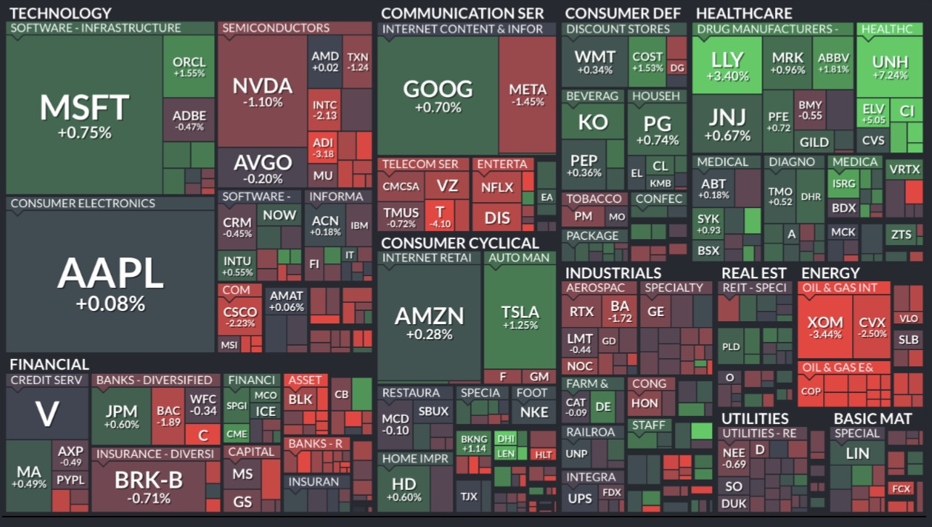

S&P 500 Sectors

~Index Performance Table~

**US CPI Release**

Equities responded positively as CPI grew by just 0.2% monthly in June and only 3% annually

The USD weakened against a basket of currencies, and DXY fell by 2.25%

Treasury Yields sank on the lower inflation data. Yields fell to 4.64% from 5.1% Last Week, whilst prices rose.

Trading View: Ticker US02Y

**Earnings Season gets underway…**

-

**Consumer Deflation In China, yes DE-flation!**

I bet you haven’t heard the word deflation for a while!

CPI fell by 0.2% in June 2023 (driven by 7.2% drop in Pork prices).

Q2 GDP grew by 6.3% compared to 2022, an underwhelming statistic as the expectation was 7.3%. This was a quarter upon quarter increase of 0.8%. Post COVID Momentum is struggling to continue

Annual CPI growth hits 0%.

Liu Guoqiang, deputy governor of the PBOC shrugged off inflation concerns. Chinese banks issued 1.81tn Yuan in June (22% increase from May). This suggests consumers are not yet feared by the threat as deflation increases the real value of debt, subsequently making it harder to repay.

It is expected that China will cut interest rates, amid concerns of the missing their 5% annual GDP Growth target in 2023.

NATIONAL BUREAU OF STATISTICS OF CHINA

The Peoples Bank of Canada (PBoC) is expected to keep the one year Loan Prime Rate at 3.55%. They are aiming to lower borrowing costs and patch up the creaking Post-Covid economy

**Other Headlines**

● Dominoes and uber partnership

● US Credit Card debt is high at $986bn, hinting that there will be a slowdown in spending (alongside high interest rates)

● TikTok aims to scale the ‘TikTok Shop’ to $20bn valuation

**OTHER HEADLINES NEEDS TO BE DONE**

|  |  |
| --- | --- |
| **Major Indices** *(taken from Trading View)* | |
| S&P 500 | **%** |
| DOW JONES | **%** |
| NASDAQ | **%** |
| FTSE 100 | **%** |
| DAX | **%** |
| Nikkei 225 | **%** |
| Shanghai Composite | **%** |

S&P 500 Sectors

**UK CPI Release**

UK inflation fell to 7.9% from 8.7% in May (vs 8.2% expected), but is still of course way higher than the 2% target. Fuel prices fell a staggering 22.7%. This positive news comes after four consecutive surprises of higher-than-expected inflation statistics. The UK lags behind the US in tackling inflation and rate hikes, but this surprise has caused GBPUSD to fall 1.83% this week. 50bps hike from the BoE is now less likely and will have to be re-calculated in line with this new data.

**Emerging Markets *Look* Cheap…**

The P/E ratio is 26% cheaper than that of developed nations, and their economies are expected to grow faster.

|  |  |  |
| --- | --- | --- |
| **2024 Estimates** | **MSCI EM** | **MSCI World** |
| **Price-to-Book Valuation** | 1.5 | 2.1 |
| **P/E** | 13.3 | 17.9 |
| **Dividend Yield (%)** | 3.0 | 2.1 |

Bloomberg

The iShares Emerging Markets ETF (EEM) is currently trading at 30.8% below its peak in February 2021

**Other Headlines**

**-** *U.S. borrowers applying for loans are being rejected at the highest rate in 5 years as lenders tighten the belt on loan requirements*

* *For the first time in years, paychecks increased more than inflation, leaving workers with a little extra spending money. (US)*

*Microsoft acquisition of Activision:* The merger may still go ahead, but no one truly knows if or when. The original deadline for the merger to complete was July 18th, however this has [**now been extended**](https://www.theverge.com/2023/7/19/23797238/microsoft-activision-blizzard-merger-agreement-extension)

The Microsoft Activision Blizzard merger has already been approved in several markets around the world. These include [**the European Union**](https://esportsinsider.com/2023/05/eu-commission-microsoft-acquisition), Ukraine, Saudi Arabia, Brazil, Serbia, Chile, Japan, South Africa, South Korea and [**China**](https://esportsinsider.com/2023/05/microsoft-activision-blizzard-china).

As of right now, the merger is currently pending in the United States. In December 2022, the [**Federal Trade Commission (FTC) preemptively sued to block the deal**](https://esportsinsider.com/2022/12/us-ftc-sues-block-activision-blizzard-microsoft-merger)

Microsoft have now won more time from British regulators to seal the ativision deal

*Earnings: BofA 2023 Q2*

*Earnings came in at $0.88 a share (vs 0.84 expected)*

Revenue came in at $25.33 billion vs. an expected $25.05 billion (an 11% increase)

FICC trading revenue jumped 18%

BofA stock (BAC) climbed 4.42% on Tuesday, but still 37.6% lower than its 3 year high in Jan 2022.

**Coming Up Next Week…**

Mondays NASDAQ 100 Rebalance

Before markets open on Monday, some larger companies will lose weight in the index, and technology megacaps will lose dominance.

Busiest week of Earnings season:

$25tn worth of companies will release their earnings

INSERT PHOTO?

**REPORT DONE**

**TITLE: FOMC MEETING**

**~Table~**

**FED rate hike:**

**Other Headlines: Tottenham owner insider trading**

**Generic to do**